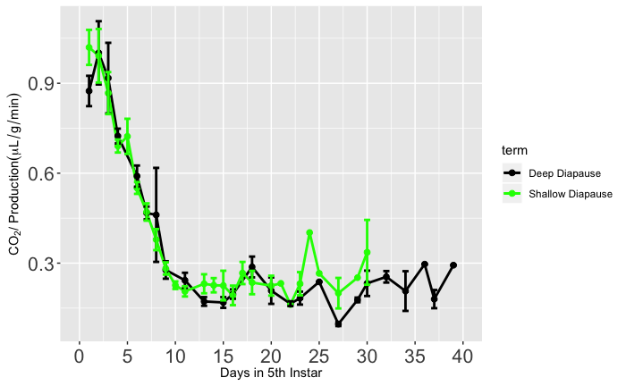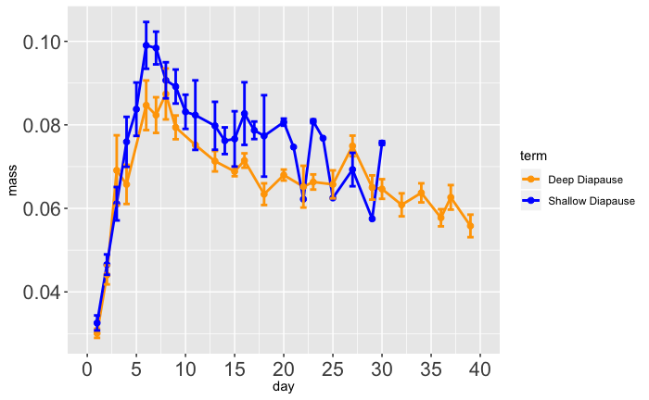

**B**

CO2  Production (µ/g/min)

Time (days)

**Deep Diapause**

**Shallow Diapause**

**A**

**Deep Diapause**

**Shallow Diapause**

Mass (g)

Time (days)